EXP 10 K MANOJ KIRAAN

240701305

Create Schedule Using Zoho Creator

Aim
To create scheduled workflows in Zoho Creator to automate periodic monitoring and notifications in the EviTrace application.

Procedure
- Open the EviTrace application in Zoho Creator.
- Navigate to Workflow → Schedules.
- Create a custom schedule named Daily_Open_Case_Review.
- Configure the schedule to run daily at 9:00 AM.
- Set the schedule to identify open investigation cases that are older than seven days.
- Configure the schedule to send email notifications to the assigned officers regarding overdue cases.
- Save and enable the schedule.
- Configure weekly and monthly schedules if required for additional periodic monitoring.
- Verify the scheduled execution and email notifications.

Output

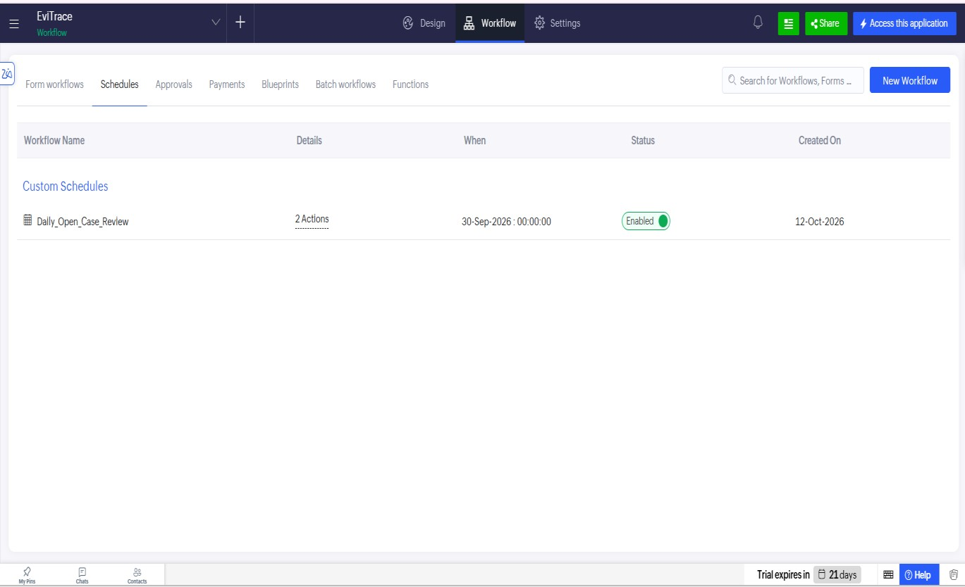
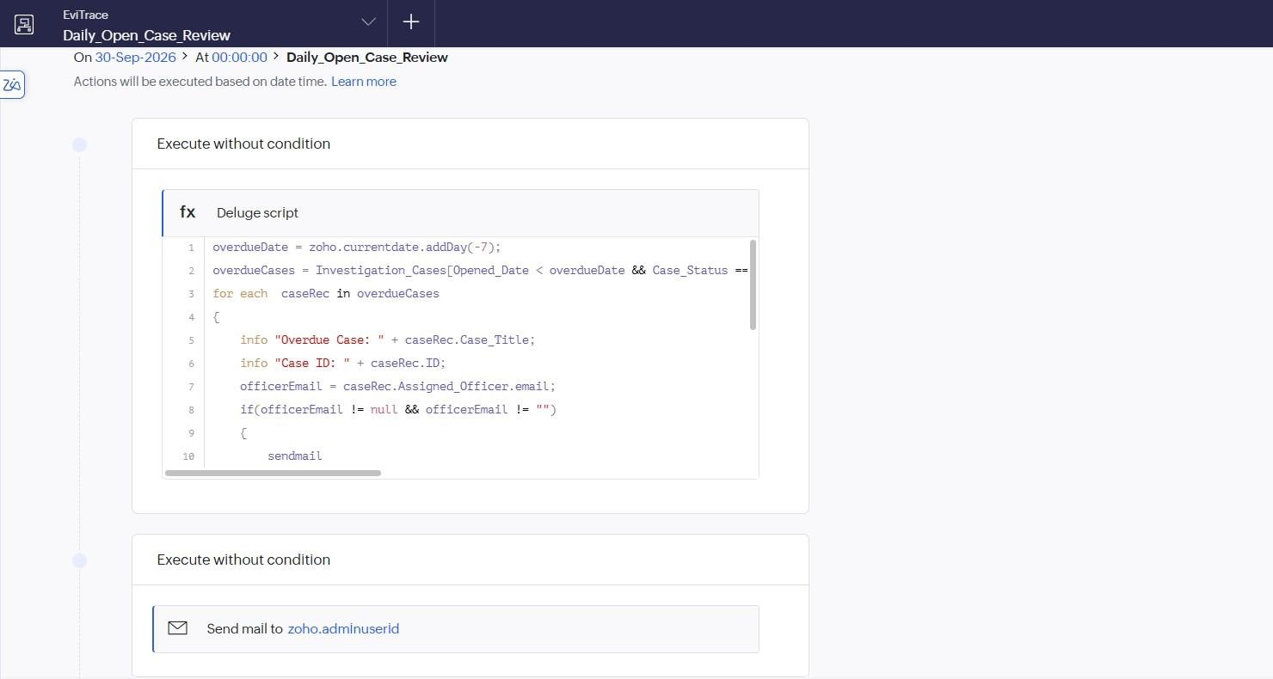

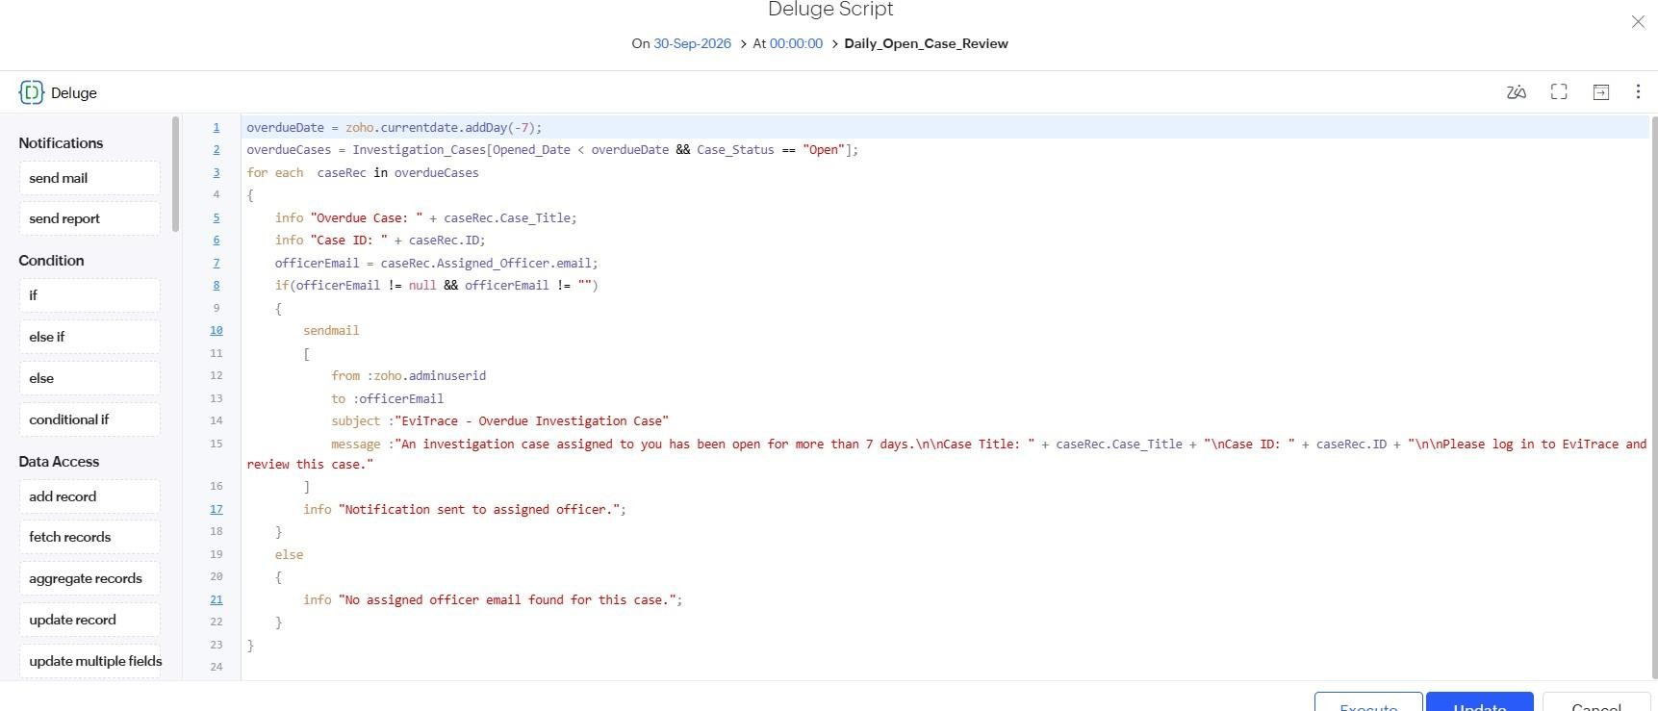
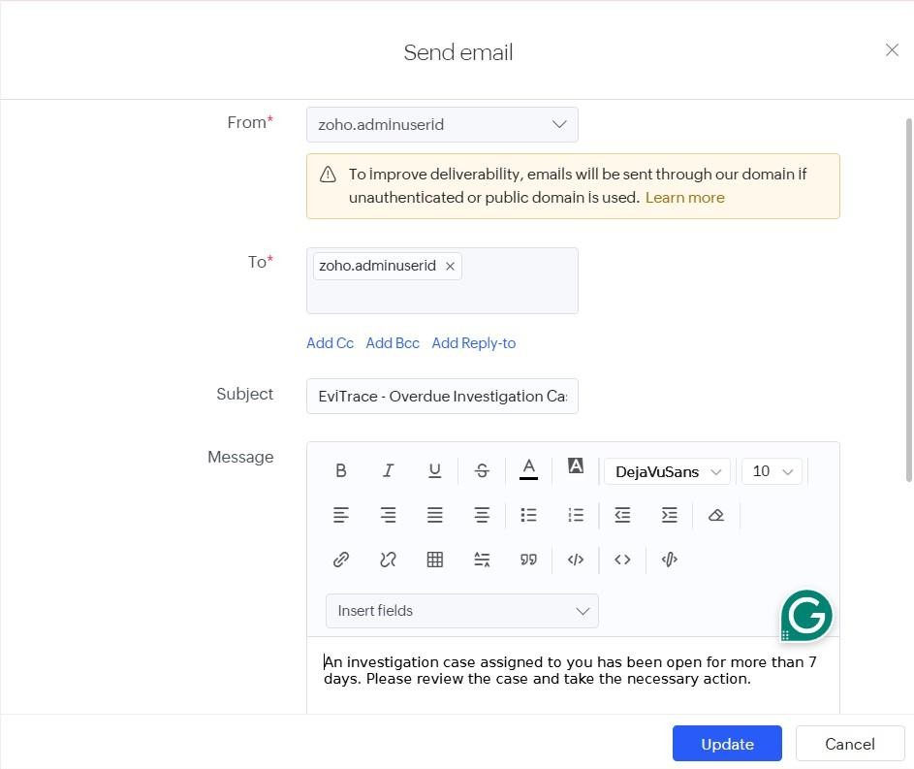

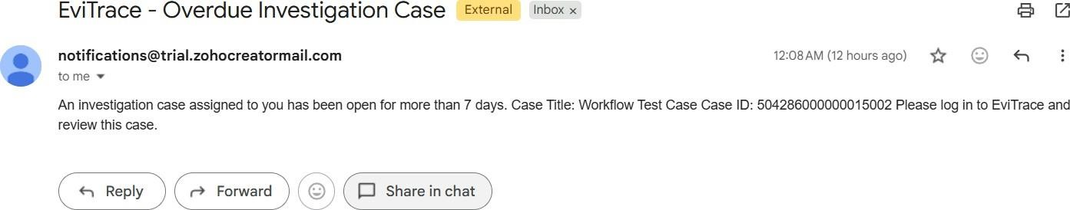

Result
The Daily_Open_Case_Review schedule was configured to monitor overdue investigation cases and notify assigned officers automatically.

